**Enemies:**

* Grunt:
  + Hit
  + Attack
  + Death
* Dog:
  + Hit
  + Attack
  + Death
* Captain:
  + Hit
  + Attack
  + Death
* Golem:
  + Hit
  + Attack
  + Death

**Bosses:**

* **Azar:**
  + Music:
    - Phase 1 Music:
    - Phase 2 Music**(Stretch)**
  + Attacks:
    - Basic
    - Ground Slam
    - Rock Throw
    - Rock Wave
  + Death
* **Dym:**
  + Music:
    - Phase 1 Music:
    - Phase 2 Music**(Stretch)**
  + Attacks:
    - Basic
    - Cloud Slash
    - Cloud Port
    - Grab
    - Summon Cloud
  + Death
* **Thwandar:**
  + Music:
    - Phase 1 Music:
    - Phase 2 Music**(Stretch)**
  + Attacks:
    - Basic
    - Drop Mine
    - Hook
    - Statis Mine
    - Rapid Shot
  + Death
* **Shuude M’ell:**
  + Music:
    - Phase 1 Music:
    - Phase 2 Music**(Stretch)**
  + Attacks:
    - Basic
    - Grab attack/Eat the player
    - Scream beam
    - Ecolocate
  + Death
* **Heart of Evolution:**
  + Music:
    - Phase 1 Music:
    - Phase 2 Music**(Stretch)**
    - Phase 3 Music**(Stretch)**
    - Phase 4 Music**(Stretch)**
  + Attacks:
    - Spawn Enemies
    - Quad Laser
    - Basic Attack(Phase 2)
    - I created you, I can destroy you dammit
    - ElectroPort
    - Dash
  + Death

**Guns:**

* Drops: Escalating explosion noises
  + Relic:
  + Legendary:
  + Epic:
  + Rare:
  + Uncommon:
  + Common:
* Modifiers: Changes the sound of the firing with a filter
  + Regular
  + Rail/Laser (WahWah)
  + Plasma (Phaser)
    - 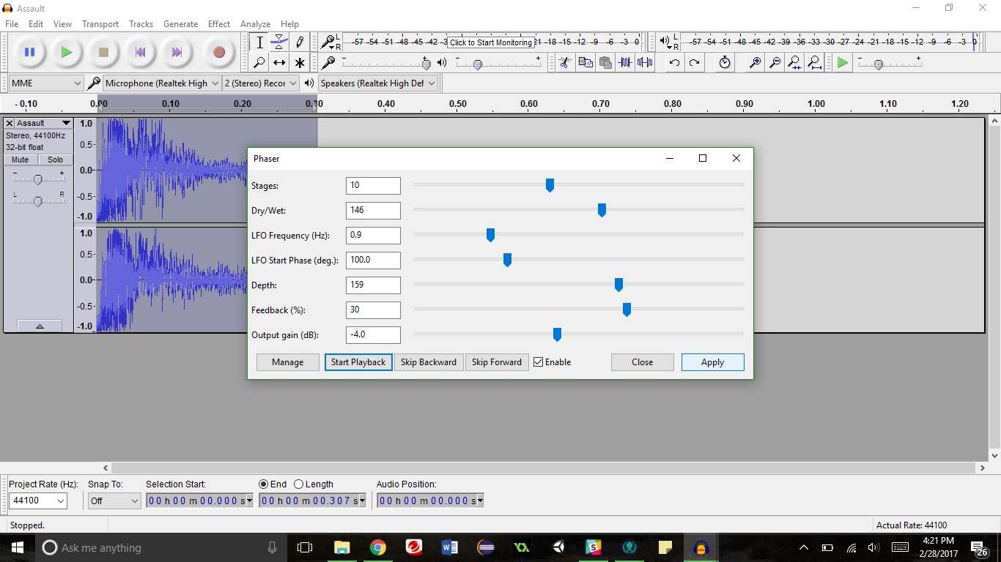
  + Scatter (x3)
  + Rocket Launcher (Add Rocket)
* SubType: Changes the overall sound of the weapon
  + Pistol:**DONE**
    - <https://drive.google.com/open?id=0BzYu8lrGAwyVTVlfX0huZU0tWHc>
  + Assault Rifle:**DONE**
    - <https://drive.google.com/open?id=0BzYu8lrGAwyVZzNGaGtjZGFIcFU>
  + Heavy Rifle:**DONE**
    - <https://drive.google.com/open?id=0BzYu8lrGAwyVcmQwQUppRWZrOVE>
  + Sniper Rifle:**DONE**
    - [https://drive.google.com/open?id=0BzYu8lrGAwyVZEVDSFhKRm9mYk](https://drive.google.com/open?id=0BzYu8lrGAwyVZEVDSFhKRm9mYkk)
  + SMG:**DONE**
    - <https://drive.google.com/open?id=0BzYu8lrGAwyVc29adjU4bTRDQlk>
  + Machine Gun:**DONE**
    - <https://drive.google.com/open?id=0BzYu8lrGAwyVR211SFk1MkRkeWM>
* Reload: Subtype
  + Pistol
  + Auto Rifle
  + Heavy Rifle
  + Sniper Rifle
  + SMG
  + Machine Gun

Depth Mechanics: Each depth has a small mechanics that may or may not have sound

* Depth 1-3
* Depth 4-6
* Depth 7-9
* Depth 10-12

Player:

* Hit
* Shield Damage
* Shield Gone
* Shield Regen
* Death
* Health regen
* Low health

General:

* Boss defeated noise
* Depth completed noise
* Death music
* Component dropped noise.

References:

* <http://soundbible.com/tags-gun.html>